**Insert Statements**

1. 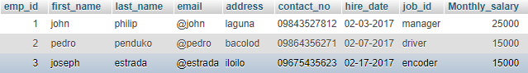Add new records from employee first name is gloria, last name to macapagal , her email @gloria ,address Isabela, contact no is 09675849374 hire date is 02-13-2018, job id is cashier and monthly salary is 16000.
   1. Solution

INSERT INTO `tblemployee` (`first_name`, `last_name`, `email`, `address`, `contact_no`, `hire_date`, `job_id`, `Monthly_salary`) VALUES ('gloria', 'macapagal', '@gloria', 'isabela', '09675849374', '02-13-2018', 'cashier', '16000');

* 1. 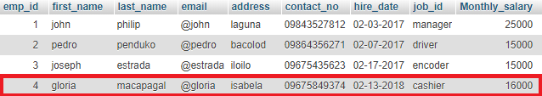Results

1 row(s) inserted.

1. Write a query to add new customer where first name is cristy, last is condez, address is Isabela, job id is miller and contact no is 09145367567.

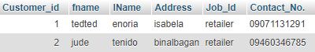

* 1. Solution

INSERT INTO `tblcostumer` (`fname`, `lName`, `Address`, `Job_Id`, `Contact_No.`) VALUES ('cristy', 'condez', 'isabela', 'miller', '09145367567');

* 1. Results

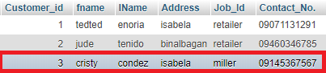

1 row(s) inserted

1. From tblcustomer create a query to add data in location last name is enoria, address is hinigaran.

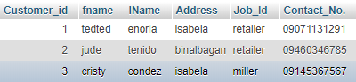

* 1. Solution

INSERT INTO `tblcostumer` (`lName`, `Address`, `Job_Id`) VALUES ('enoria', 'hinigaran', 'dealer');

* 1. Results

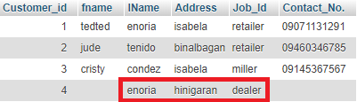

1 row inserted.

1. Create a query to insert three rows in column rice code, rice variety, rice price, rice total, amount, change and date in the same time on rice history.

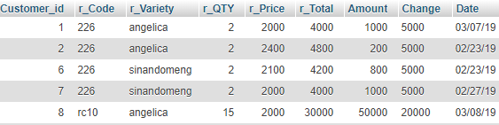



* 1. Solution

INSERT INTO `ricehistory`(`r_Code`, `r_Variety`, `r_QTY`, `r_Price`, `r_Total`, `Amount`, `Change`, `Date`) VALUES ("rc10","rosana",10,2200,2200,30000,27800,"03/9/19"),("222","burdagol",10,2000,20000,20000,0,"03/8/19"),("216","senandomeng",5,2100,10500,11000,500,"03/8/19");

* 1. Results

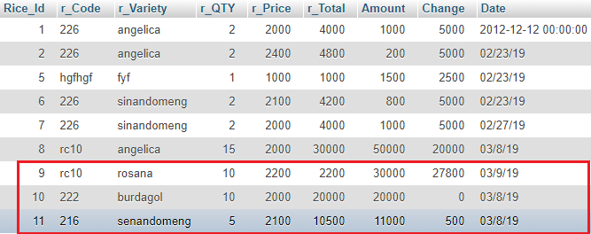

3 row(s) inserted.

1. Write a query to add data from tblcustomer in location first name to sharia , last name to sablaon and job id to farmer.

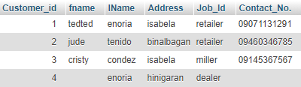

* 1. Solution

INSERT INTO `tblcostumer` (`fname`, `lName`, `Job_Id`) VALUES ('shaira', 'sablaon', 'farmer');

* 1. Results

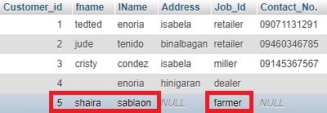

1 row inserted.